
FAKULTI KOMPUTERAN

UNIVERSITI TEKNOLOGI MALAYSIA

FINAL EXAM

SEMESTER I 2022/2023

COURSE CODE | : SECD2523
COURSE NAME | : DATABASE
YEAR / PROGRAM | : 2/SECB, SECJ, SECV, SECR
TIME | :
DATE | :
PLACE | :

INSTRUCTION TO STUDENTS:

- Fill in your particulars in the question-and-answer booklet.

Name
IC No.
Matrix No.
Year / Program
Course Code/ Section
Lecturer

- Answer ALL questions in the ANSWERING BOOKLET given.
- This paper consists of THREE parts:
Part A: 20 MCQ Questions
Part B: 5 Structured Questions
Part C: 1 CASE Study questions
- Submit BOTH question-and-answer booklet at the end of the exam.
____________________________________________________________________________
This paper consists of 26 pages printed including this page

PART A: MULTIPLE CHOICE QUESTIONS (MCQ) | [20 MARKS]

PART B: STRUCTURED QUESTIONS | [60 MARKS]

QUESTION 1 | [10 MARKS]
- Draw the Entity Relationship Diagram (ERD) for EACH of the following situations:
- Each donor will donor one type of blood and each type of blood will be donated by at least one or more donor.
- A doctor will treat one or more patients and each patient will be treated by only one doctor.
- Each customer can rent one or more cars and each car will be rented by at most one customer.
- Many nurses can be monitored by a nurse.
 | (4 Marks)
- The following ERDs have a few errors. Circle and describe SIX (6) errors below.
(Note: answer in the provided attachment (Appendix 1))

No. | ERD
i. | 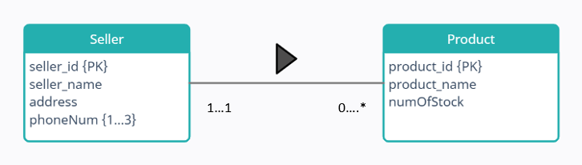
ii. | 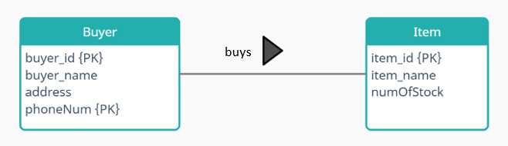
iii. | 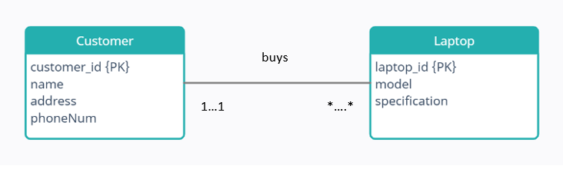

 | (6 Marks)

QUESTION 2 | [10 MARKS]
- There are four (4) categories of constraints in Enhanced Entity Relationship Diagram (EERD).

Choose TWO (2) categories and provide ONE (1) example for each category.
 | (4 Marks)
- A library keeps all the study materials for students and staff references. One of study material is publication. Publication can be categorized as book and article. Book cannot fall into the other category. The data stored on book includes book title, book category and book publisher. While article have article title and keyword. The publication ID uniquely identify the book and article publication information. Then the date of publication also recorded in the publication.

- Based on the description above draw the EERD (state participation and disjoint constraint, if any).
- What is the participation and disjoint constrains for the above EERD?

 | (6 Marks)

QUESTION 4 | [20 MARKS]
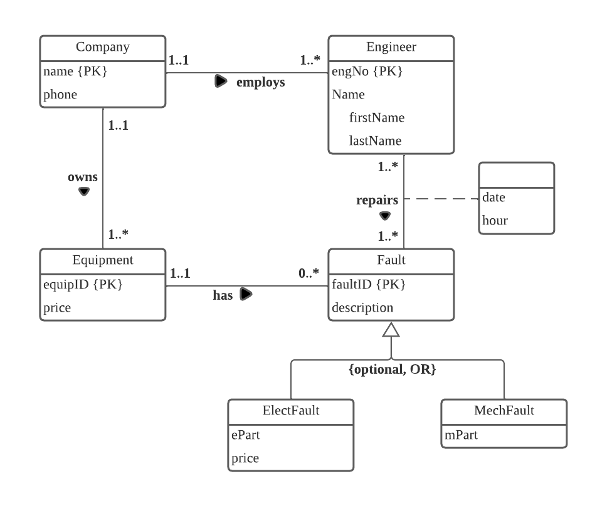
Figure 1: ERD Company A

Based on the ERD Company A given in Figure 1, answer all the following questions:
- For relationships owns, employs, and has, states the type (weak or strong) of each entity that participates in the relationships. Provide your answer in the given format in Table 1.

Table 1: Format Answer
Relationship | Entity 1 - Type | Entity 2 - Type
owns
employs
has

 | (3 Marks)
- Derive all relations schema from the ERD in Figure 1. State the primary key and foreign key (if any) for each schema.
 | (7 Marks)
- Draw the logical ERD based on relations schema derived in Question 1(b).
 | (10 Marks)

QUESTION 5 | [20 MARKS]
Table 2: Details of patient dental appointment
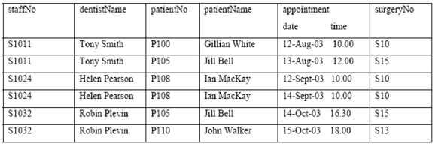
- The table shown in Table 2 is susceptible to update anomalies. Provide examples of insertion, deletion, and modification anomalies.
 | (8 Marks)
- Describe and illustrate the process of normalizing the table shown in Table 1 to 3NF. State any assumptions you make about the data shown in this table.

 | (12 Marks)

PART C: CASE STUDY QUESTION | [20 MARKS]

The Open University Malaysia has offered their students the newly built accommodation in the university compound. The accommodation management system is called University Hostel Management, which consist of tables Student, Lease, Hall, Flat, Room and Invoice. Please refer to the normalized tables and answer the questions below.

Student (matricNo, fName, lName, street, city, postcode, DOB, gender)
- Primary Key matricNo
- Foreign Key lNo references Lease(leaseNo)

matricNo | fName | lName | street | city | postcode | DOB | gender | lNo
MC454693 | Azrul | Hakim | Jalan Indah 2 | Kuala Lumpur | 56100 | 21 June 1987 | Male | L01
MC129048 | Maimon | Naim | Jalan Paya 81 | Batu Pahat | 45000 | 30 May 1981 | Female | L02
PC284980 | Nabil | Zain | Jalan Cemerlang 1 | Ayer Keroh | 32900 | 6 April 1990 | Male | L03
MC683469 | Adi | Bahrin | Jalan Menteri 3 | Johor Bahru | 88100 | 2 August 1988 | Male | L04
UC752371 | Zatil | Ahmad | Jalan Indah 4 | Kuala Lumpur | 56100 | 16 November 1982 | Female | L05

Lease (leaseNo, duration, matricNo, placeNo, dateEnter, dateLeave)
- Primary Key leaseNo
- Foreign Key mNo references Student(matricNo)
- Foreign Key pNo references Room(placeNo)

leaseNo | duration | mNo | pNO | dateEnter | dateLeave
L01 | 6months | MC454693 | P01 | 1-01-22 | 30-6-22
L02 | 6months | MC129048 | P02 | 1-01-22 | 30-6-22
L03 | 12months | PC284980 | P03 | 15-01-22 | 14-01-23
L04 | 8months | MC683469 | P04 | 15-01-22 | 14-08-22
L05 | 3months | UC752371 | P05 | 1-06-22 | 31-08-22

Hall (halINo, hName, hAddress, hTeINo)
- Primary Key halINo

hallNo | hName | hAddress | hTelNo
h0101 | Hall Cendana | Jalan Rahman | 07-89294000
h0102 | Hall Sapura | Jalan Razak | 07-89295000
h0103 | Hall Cempaka | Jalan Abdullah | 07-89296000

Flat (flatNo, fAddress, noOfRooms)
- Primary Key flatNo

FlatNo | fAddress | noOfRooms
F001 | Flat Merpati | 3
F002 | Flat Pipit | 4
F003 | Flat Helang | 2

Room (placeNo, roomNo, monthlyRent, flatNo, hallNo)
- Primary Key placeNo
- Foreign Key halINo references Hall(hallNo)
- Foreign Key flatNo references Flat(flatNo)

placeNo | roomNo | monthlyRent | fNo | hNo
P01 | 01-23 | 500 | F001 | h0101
P02 | 02-56 | 60 | F002 | h0102
P03 | 03-11 | 60 | F003 | h0103
P04 | 04-24 | 700 | F002 | h0102
P05 | 06-35 | 300 | F003 | h0103

Invoice (invoiceNo, semester, paymentDue, datePaid, paymentMethod, leaseNo)
- Primary Key invoiceNo
- Foreign Key lNo references Lease(leaseNo)

invoiceNo | semester | paymentDue | datePaid | paymentMethod | lNo
PO79900 | 3 | 30-Sept-2023 | 15-Sept-2023 | Cash | L01
PO35850 | 2 | 30-Sept-2023 | 1-Sept-2023 | Online transfer | L02
PO84909 | 1 | 1-June-2023 | 2-June-2023 | Card credit | L03
PO09786 | 2 | 30-Oct-2023 | 29-Oct-2023 | Online transfer | L04
PO86452 | 2 | 30-Sept-2023 | 30-Sept-2023 | Debit card | L05

Write/Construct the SQL statements for each query in questions 1 to 9:
- A list of all hall number, hall name, hall address and their phone number.
(2 Marks)
- For Flat Merpati from table Flat, retrieve the flat number, flat address and number of rooms.
(2 Marks)
- For each of female students that have been applying for an accommodation in university, list their first name, last name, matric number, birth date and home city.
(3 Marks)
- Display the invoice number, date paid and payment due for second semester students who have made the accommodation payment using online transfer. Use Invoice Number, Date Paid and Payment Due from table Invoice as the column aliases.
(2 Marks)
- Display the student first name and their gender alphabetically in order of student name. Use Student Name and Student Gender an alias for your column headings.

(2 Marks)
- Display all the information about student information and their invoice.

(2 Marks)
- A list of room number which has the floor number in their hall number and their rental rate. Sort the list by their rental rate in ascending order.

(2 Marks)
- Use an ON clause to join the student and lease table so that you display the matric number, student first name, student last name, city, postcode, DOB, gender, lease number, leaseNo, duration, place number, date enter the place and date leaving the place. However, show the results for the student that rent the room form 6 months only

Find the error in the SQL statement below. Then, write the correct SQL statement.

SELECT matricNo, fName, lName, city, postcode, DOB, gender, lNo
FROM student JOIN lease
ON (lNo = lease_no)
WHERE monthlyrent = 60;

(3 Marks)
- Produce the result of the following SQL statement:

SELECT invoiceNo, semester and paymentMethod
FROM Invoice;

(2 Marks)

APPENDIX 1

Circle the error and describe SIX (6) errors below.

No. | ERD
i.
ii.

iii.

Description on errors:

